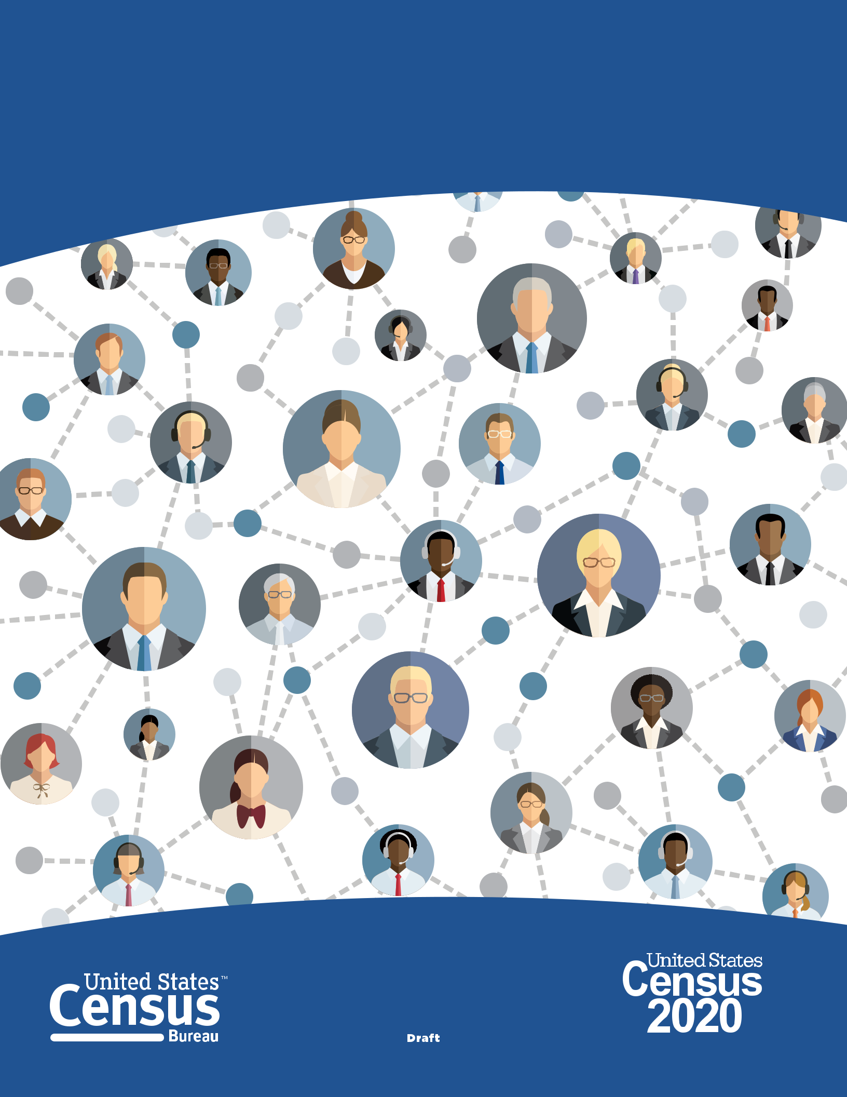20XX Census Complete Count Committee

Training Manual

D-1255

TM

CONTENTS

Introduction . . . . . . . . . . . . . . . . . . . . . . . . . . . . . . . . . . . . . . . . . . | ..... | . . | 1
Chapter 1: Decennial Census Overview. . . . . . . . . . . . . . . |  |  | 3
Chapter 2: SCCCs/CCCs: Overview. . . . . . . . . . . . . . . . . |  |  | 5
Chapter 3: Forming State Complete Count Commissions and |  |  | 7
Complete Count Committees . . . . . . . . . . . . . .
Chapter 4: Timeline . . . . . . . . . . . . . . . . . . . . . . |  |  | 11
Chapter 5: Planning Your Work and Working Your Plan. . . . . . . . . |  |  | 15
Chapter 6: 20XX Census Integrated Communications Campaign. . | .... |  | 19
Chapter 7: What to Expect From Your U.S. Census Bureau Staff Liaison. . |  | . | 21
Chapter 8: Summary and Closing . . . . . . . . . . . . . . . . . |  |  | 23

Introduction

COVERED TOPICS

The State Complete Count Commission/Complete Count Committee (SCCC/CCC) manual provides information to educate SCCC/CCC leaders and members about the 20XX Census and their role in the committees. The goal of this manual is to equip SCCC/CCC leaders with the information they need to train their members on ways they can help promote participation in the census.

Content covers a combination of topics, such as:

- Background and structure of the committees.

- Recommended subcommittees.

- Resources and tools available to help drive partici-pation in the 20XX Census.

- Lessons learned from the 2010 Census.

- Discussion on community needs, developing strat-egies, and creating an effective work plan.

This manual also includes details about the pur-pose of the decennial census and the Integrated Communications Campaign in support of the 20XX Census.

About This Training

The Regional Partnership staff will use this manual to help state, local, and tribal governments and com-munity leaders/members form and manage effective SCCC/CCCs. On the following pages you will find background information on the U.S. Census Bureau, details about the decennial census, and tips for ensuring a successful count in 20XX. The goal of this manual is to “train the trainers,” so SCCC/CCC leaders

are fully equipped to manage the committees and train their own committee members to lead and oper-ate effectively.

The following documents should be included in the training package:

- SCCC/CCC Guide D-1280

- SCCC/CCC Program Brochure D-1256

- SCCC/CCC Training Manual D-1255

Overview of the SCCCs/CCCs

The SCCCs/CCCs are one of the core strategic ele-ments of the Census Bureau's partnership program for the 20XX Census. A SCCC differs from a CCC because it is formed by an executive order or by a legislative act within a state.

These committees exist to plan and implement locally-based outreach campaigns that raise aware-ness of the census and ultimately drive self-response and participation rates. The SCCCs/CCCs can achieve this goal through grassroots outreach efforts that promote the importance and benefits of responding to the census. One of the key reasons these commit-tees are effective in raising awareness is because of the members’ knowledge and understanding of what it takes to engage and inspire others within their community.

The Census Bureau Partnership Specialists will serve as technical advisors and information resources for all SCCCs/CCCs; the daily management responsibilities rests solely with the highest elected official or com-munity leader serving as chair of the SCCC/CCC.

20XX Census Complete Count Committee Training Manual | 1

Background and Structure of SCCCs/CCCs

The highest elected officials of every state, local, and tribal government will receive a letter from the Census Bureau Director requesting and encouraging them to partner with the Census Bureau and to form a SCCC/CCC for the 20XX Census.

State and local government SCCCs/CCCs consist of influential community members and trusted voices who are appointed by the highest elected govern-ment official. Typically, committee members are experts in the following areas:

- Government

- Education

- Media

- Technology

- Community organizations

- Workforce developments

- Faith-based institutions

- Businesses

- Other, based on community needs

The Census Bureau encourages community leaders in hard-to-count areas to form CCCs. Hard-to-count areas may, for example, have:

- Hidden or overcrowded housing.

- Populations that speak little or no English.

- Off-campus apartments.

- New immigrant populations.

- People displaced by natural disasters such as floods, fires, and hurricanes.

- Children under 5.

- Gated communities.

One of the principal benefits of the SCCC/CCC pro-gram is the synergistic effect of working together as trusted voices in their communities to spread the word about the importance of the census and value of participating/being counted in the census process. Every time a SCCC/CCC is established, the Census Bureau is one-step closer to conducting the most successful census ever.

Getting an accurate count can't be achieved without local involvement and support. Establishing a SCCC/

- can significantly help ensure your community is counted.

2 20XX Census Complete Count Committee Training Manual

Chapter 1

DECENNIAL CENSUS OVERVIEW

U.S. Constitution

The United States began conducting a census of population and housing in 1790. The U.S. Constitution, Article 1, Section 2, mandates an apportionment of representatives among the states for the House of Representatives every 10 years.

Apportionment is the process of dividing the 435 seats in the U.S. House of Representatives among the 50 states. By law, the U.S. Census Bureau must deliver a report of population counts to the president of the United States within 9 months of Census Day (on

or before December 31). The report will provide the population counts by state and the number of seats in the U.S. House of Representatives apportioned to each state.

information during or after employment, and the pen-alty for wrongful disclosure is up to 5 years imprison-ment and/or a fine of $250,000.

Using Technology in the 20XX Census

There are some important changes in 20XX:

- For the first time, you will be able to respond online, by mail, or by phone.

- We will use data that the public has already pro-vided to cut down on in-person follow up visits to nonresponding households.

- We are building a more accurate address list and automating our field operations—all while keeping your information confidential and safe.

The Census Is Confidential and Required by Law

All responses to Census Bureau surveys and cen-suses are confidential and protected under Title 13 of the U.S. Code. Under this law, the Census Bureau is required to keep respondent information confidential. We will never share a respondent’s personal informa-tion with immigration enforcement agencies, like ICE; law enforcement agencies, like the FBI or police; or allow it to be used to determine their eligibility for government benefits. The results from any census or survey are reported in statistical format only.

Individual records from the decennial censuses are by law (Title 44, U.S. Code) confidential for 72 years.

Furthermore, under Title 13, U.S. Code, all Census Bureau employees swear a lifetime oath to pro-tect respondent data. It is a felony for any Census Bureau employee to disclose any confidential census

The Many Uses of Census Data

Census data are used in many ways. Some examples include:

- Distribution of more than $675 billion annually in federal funds back to state, local, and tribal governments.

- Redistricting of state legislative districts.

- Forecasting of future transportation needs for all segments of the population.

- Determining areas eligible for housing assistance and rehabilitation loans.

- Assisting federal, tribal, state, and local govern-ments in planning and implementing programs and services and emergency response.

- Designing facilities for people with disabilities, the elderly, and children.

20XX Census Complete Count Committee Training Manual | 3

Chapter 2

SCCCs/CCCs:

Overview

THE IMPORTANCE OF COMPLETE COUNT COMMITTEES

What Is a SCCC/CCC?

A State Complete Count Commission/Complete Count Committee (SCCC/CCC) is a volunteer com-mittee established by tribal, state, and local gov-ernments and community leaders or organizations to increase awareness and motivate residents to respond to the 20XX Census. SCCCs/CCCs serve as state and local “census ambassador” groups that play an integral part in ensuring a complete and accurate count in the community in the 20XX Census. Success of the census depends on community involvement at every level. The U.S. Census Bureau cannot conduct the 20XX Census alone.

Government SCCC/CCC

The first type of SCCC/CCC are Tribal Complete Count Committees, State Complete Count Commissions, and local government complete count committees. These are committees of government officials and community members appointed by the highest elected officials of a tribal, state, or local government for the purpose of developing and imple-menting a census awareness campaign that motivates their communities to complete the census question-naire thoroughly and return it in a timely manner. Government SCCCs/CCCs may be small (5–20 mem-bers), medium (20–50 members), or large (50–100 or more members). State Complete Count Commissions differ from Complete Count Committees because they are initiated through the legislature or by execu-tive order.

Community-Based CCC

The second type of CCCs are comprised of a team of community leaders and/or organizations brought together to design an outreach plan for hard-to-count areas or populations in their community. Their focus is to encourage individuals in their community to respond to the 20XX Census by Internet, mail, or by phone. Community CCCs are usually small to medium in size with about 5 to 30 members.

Lessons Learned From the 2010 Census

Since the 1980 Census, Complete Count Committees have played a major role in raising awareness of the census among all groups and populations. The exper-tise, influence, knowledge, and experience of commit-tee members are invaluable resources to a complete and accurate count. The following are lessons learned and recommendations for future committees:

- These committees were a prime example of part-ners taking ownership of the census process and leading outreach efforts. Partnership specialists said the Complete Count Committee Initiative was among the most effective strategies for compre-hensively reaching the hard-to-count populations.

- Although the CCC Initiative was very successful, it needs to start sooner. Previously, it began 2 years before Census Day. By starting earlier, it allows for better integration into organization planning and budgets.

20XX Census Complete Count Committee Training Manual | 5
Recommendations for Successful SCCCs/ CCCs

The Census Bureau has learned from previous cen-suses and recommendations for success in 20XX. These recommendations are based on information gathered from the committees, focus group ses-sions, and summary reports submitted by Partnership Specialists.

- Customize and design the committee to reflect a true snapshot of the community.

- Use technology effectively. Communicate with committee members through electronic mediums.

- Include diverse perspectives to achieve objectives. Assess which groups—locally and nationally—are able to provide support and assistance.

- Choose a committee chair who is committed, knowledgeable, and active in the community.

- Select Subcommittee Chairpersons who are purpose-driven, result oriented, and gets results.

- Review CCC activities in your area from the 2010 Census. Repeat what worked well. Eliminate what did not work well. Modify activities and incorporate new innovative activities in your plan, as needed.

- Incorporate a census awareness in all existing com-munity festivals and activities scheduled.

- Recruit experienced members to motivate and support new members.

- Keep detailed records of SCCCs/CCCs’ strategies and activities so that the program can be better assessed and best practices be replicated.

6 20XX Census Complete Count Committee Training Manual

Chapter 3

Forming State

Complete Count

Commissions and

Complete Count

Committees

HOW TO GET STARTED

SCCC/CCC Structure

The U.S. Census Bureau’s recommended structure for State Complete Count Commissions/Complete Count Committees (SCCC/CCC) maximizes the effective-ness of committee outreach strategies in their com-munities. However, the committees are encouraged to adopt their own structure based on the unique com-munity needs and develop a strategy to meet them. A committee may choose to create subcommittees dedicated to these needs. Regardless of the struc-ture, government committees should include mem-bers with experience in the following areas:

- Government

- Workforce development

- Faith-based community

- Education

- Media

- Technology

- Community organizations

- Business

People who are selected to serve on the SCCC/CCC and the subcommittees are expected to communi-cate the importance of the 20XX Census to their peer groups and guide them in implementing strategies to increase the count in their respective communities. The committee will use multiple strategies and tactics to deliver key messages during different phases of the census.

State Complete Count Commissions

State Complete Count Commissions are governed the highest level within each state. Governors create the commission by appointing individuals to serve as members on the commission. State officials often have a good understanding of the economic impact of a complete count and are highly motivated to develop a comprehensive outreach plan. The commis-sion is usually chaired by an individual designated by the Governor, such as the Governor’s Liaison or staff from the State Data Center. State Complete Count Commissions may be fairly large with anywhere from 20 to 100 members. SCCCs consist of influential com-munity leaders who are charged with developing a census awareness campaign that:

- Encourages county and municipal governments to form CCCs.

- Raises awareness of the census throughout the state.

- Motivates every household in the state to partici-pate in the census by responding online, by mail, or by phone.

- Increases the state’s self-response rate.

The size of the SCCC is determined by each state. In addition, many governors and the legislature may allocate funding to support the activities of the SCCC. States view this funding as a sound investment in the future. Failure to count each person living in the state could result in a substantial loss of revenue for the next decade for state and local governments.

20XX Census Complete Count Committee Training Manual | 7

The commission members may include:

- A governor or his/her designee.

- Members such as majority/minority leaders of the state house or designee, heads of major counties, mayors of major municipalities, heads of philan-thropic organizations, and heads of major business associations and community organizations.

State commissions may operate with or without sub-committees. However, many state governments prefer the subcommittee structure. In those cases, once the SCCC members have been identified, chairpersons may divide the members into subcommittees based on activities that the commission plans to undertake. For example, a media subcommittee may be formed to identify local officials and other persons of influ-ence to record public service announcements (PSAs) and appear on local television and radio shows about the census. An education subcommittee might target schools, colleges, and universities with promotional materials and ensure that Statistics in Schools materi-als are used by K–12 schools across the state. Another subcommittee may be a business subcommittee that targets businesses and encourages them to post census materials and sponsor local events. Other pos-sible subcommittees may include a faith-based focus to reach religious groups in a community or a youth focus to target organizations providing services to children such as Head Start or day care centers.

It is important to note the type of subcommittee cre-ated is based on the needs of the state or the focus of the commission.

Tribal or Local Government CCCs

Tribal and local Government CCCs are formed by the highest elected official in a local government, regard-less of size. This includes tribal leader or chairman, local governments in cities, counties, towns, and vil-lages. Tribal and local government CCCs are charged with developing and implementing a census aware-ness campaign that motivates every person living in every household to be counted in the 20XX Census in a timely manner.

Community CCCs

Community CCCs are usually formed in support of specific hard-to-count communities. Grassroots community organizing efforts are essential to reach

populations who have not responded well in previ-ous censuses or who have a history of being under-counted in the census. In some instances, community CCCs are formed to fill a gap in areas where there is no government sponsored CCC.

Community CCCs usually include representation from the following areas of the community:

- Businesses.

- Educators.

- Media representatives.

- Faith-based organization leaders.

- Community-based organization leaders.

- The entire group selects the chairperson and sub-committee chairpersons. Committee members determine the committee size.

Key Points

Key points to remember about the SCCC/CCC struc-ture include:

- The committees should be all-inclusive, addressing the various racial, ethnic, cultural, and geographic considerations of the community.

- The Census Bureau staff serve as liaisons and information resources for the committees. The Census Bureau provides technical assistance in developing the committees but do not manage the committees.

- The committee operations are governed by the highest elected official or community leader. Responsibility then falls to the chairperson, the committee members, and finally to the community.

Recommended Subcommittee Structure

It is essential that the committees address and reflect key facets of the community. The decision to form subcommittees is based on community need and the opportunities and challenges in reaching areas or populations that may not respond or may potentially be undercounted. The Census Bureau recommends including subcommittees focused on:

- Government

- Business

- Education

- Housing

8 20XX Census Complete Count Committee Training Manual

- Media, communications, and technology

- Faith-based

- Community organizations

- Senior citizens

- Outreach

- Recruitment

- Philanthropic

It is important to note that in the past, committees have also created subcommittees devoted to data and maps, youth, homeless, LGBTQ, veterans, special housing, recruiting, immigrants, and homeowners associations. These subcommittees can help reach the most challenging areas to count.

Different subcommittee structures and sizes are appropriate for different types of committees. The subcommittee structure is determined by the size and needs of the community it serves.

If the SCCCs/CCCs choose to form subcommittees, here are examples of the various subcommittees structures:

Government Subcommittee

Focus

- Represents local government in all programs between the Census Bureau and local government, such as new construction program and others.

- Elected officials are aware of and are included in committee activities.

Composition

- Elected officials, city/county planners, demogra-phers, cartographers, and municipal employees.

Education Subcommittee

Focus

- Creates, facilitates, and coordinates census aware-ness activities among the various educational lev-els from prekindergarten to post-graduate, includ-ing day care centers, Head Start programs, and parochial, private, charter, and home schools.

- Ensures the wide distribution and awareness of the Statistics in School program and materials.

- Works with area colleges and universities to imple-ment Census Bureau’s Higher Education program and raise awareness among students housed on and off campus.

- Raises awareness through adult education and English Language Learner Programs.

Composition

- Educational leaders, superintendents, principals, school district administrators, charter school administers, teachers, students, Parent Teacher Organizations (PTOs), teachers organizations, and university housing coordinators.

Faith-Based Subcommittee

Focus

- Facilitates and coordinates census awareness activities between faith-based institutions and organizations, ministerial alliance, ecumenical councils, and seminary administrators.

Composition

- Faith-based leaders from ALL denominations, ministerial alliances, ecumenical councils, and seminary administrators.

Media, Communications, and Technology Subcommittee

Focus

- Assists the committee in communicating census messages to ALL.

- Facilitates communication of the committee mes-sages through multiple channels, such as ethnic media, local newsletters, electronic bulletins, local Web sites, and utilizing different social media venues.

- Assists the community organizations in utilizing census toolkit materials that enable organizations to innovate.

- Countering false and misinformation about the census.

Composition

- Local media representative, communication direc-tors, bloggers, publishers and editors of neighbor-hood newspapers, graphic designers, social media users, and ethnic media representatives.

Community Organizations Subcommittee

Focus

- Coordinates the building of coalitions with com-munity organizations that serve the special needs of various racial, ethnic, cultural, civic, fraternal,

20XX Census Complete Count Committee Training Manual 9

and advocacy groups, immigrants, and people with disabilities.

Composition

- Executive directors from community organiza-tions, Community Block Grant (CDBG) directors, leaders of fraternities and sororities, membership and nonmembership organizations, and advo-cacy groups. (Most major cities have offices that cater to the needs of immigrant, refugee, and minority populations, i.e., Mayor's Office of the Latino, African Affairs (DC), and Department of Neighborhood/Super Neighborhood councils (City of Houston.)

Business Subcommittee

Focus

- Coordinates and generates census awareness activities that involve businesses of all types and sizes.

- Creates a unifying element that touches every household within the community.

- Encourages their employees to respond to the census.

Composition

- Chambers of Commerce, business alliances, neigh-borhood business associations, franchise owners and operators, financial institution officers (i.e., bank managers), owners of small community and ethnic businesses, and utility company managers.
Recruitment Subcommittee

Focus

- Distributes recruiting materials received from Partnership Specialists and assists Partnership Specialists in securing donations for space to train employees.

- Publicizes Census Bureau job openings using all available resources, including local festivals and job fairs.

- Enhances the ability of census to plug into existing recruiting resources.

Composition

- Employment security staff and staff from job train-ing agencies (i.e., job training agencies such as Goodwill, United Way, and city, state, and federal employment agencies).

10 20XX Census Complete Count Committee Training Manual

Chapter 4

Timeline

KEY COMMUNICATIONS PHASES

This timeline describes some of the phases of the 20XX Census Campaign, SCCCs/CCCs may find beneficial in developing outreach strategies for their work plan.

Education Phase Awareness Phase Motivation Phase

Education Phase (2018–2019)

The education phase is the period from 2018 through December 2019. During this period, key community and municipal leaders receive training, informational materials, and one-on-one meetings with the U.S. Census Bureau partnership staff about the impor-tance of the census and the need for local support to ensure a successful count.

Awareness Phase—April 2019

The awareness phase of the 20XX Census officially starts in January 20XX. This phase overlaps with the education phase. Beginning April 1, 2019, government and community leaders throughout the nation participate in activities highlighting the message that the 20XX Census is easy, important, and safe.

This is also the period when the SCCC/CCC leader-ship develops the mission and message with all mem-bers. They identify how to bring awareness to the community.

The public must understand that the census is their civic responsibility that affects people of all ages, races, cultures, and ethnicities, regardless of citizen-ship status. Census data effects the entire community.

Motivation Phase (March–May)

The motivation phase starts in March 20XX. During this phase, the committees implement activities of the work plan through their government, faith, com-munity, business, media, and recruitment partners. This guarantees every person living in the United States will encounter census messages during time of work, play, leisure, school, and worship.

April 20XX

In April 20XX, the focus is to motivate each house-

hold to take ownership of the census, make a con-

scious decision to participate, know where to go for

assistance in answering the census, and be poised

and ready to answer questions on April 1, 20XX.

20XX Census Complete Count Committee Training Manual | 11

April 1, 20XX—Census Day is here!

One of the primary goals of the CCC is to increase the response rate to the 20XX Census and reduce the number of households that do not complete their census.

Reminder Phase (May–July 20XX)

Around mid-May 20XX, final preparation will be made to follow-up with households that did not participate in the census. This operation is called “nonresponse follow-up.”

May 20XX

The nonresponse follow-up operation will be the focus starting in May 20XX.

The objective is to get nonresponse households to cooperate on the first visit.
Awareness Phase

Action Steps for January 20XX

- Hold monthly meetings and subcommittee meetings.

- Finalize plans for activities surrounding Census Day activities.

- Review task lists and subcommittee plans.

- Proceed with 20XX activities.

- Finalize plans for activities to encourage households to complete and return the census questions.

- Develop and finalize plans for motivating house-holds who do not return their questionnaire to cooperate with census takers during nonresponse follow-up activities.

July 20XX

As the census operation winds down, special thank-you sessions for the work of the census will be held throughout the nation.

Timeline and activities

These are just a few examples of activities or action steps for the committees. They are not all inclusive, just examples to get the committees started and thinking about what activities will work best in the community served.

Education Phase

Action Steps for Now Through December 2019

- Conduct SCCC/CCC training for members.

- Develop a work plan for promoting the census and motivating participation in your community.

- Hold daily/weekly meetings to report on tasks and other activities, including subcommittee reports as appropriate.

- Proceed with census awareness-building activities generated by the committee or subcommittees.

- Evaluate the effectiveness of the SCCC/CCC activ-ities and adjust accordingly.

- Saturate the community with at least one census awareness-building activity each month.

Motivation Phase

Action Steps for March 20XX–April 20XX

- Hold regular SCCC/CCC and subcommittee meetings.

- Review and modify as needed plans for question-naire delivery and Census Day activities.

- Finalize plans for all activities scheduled for March and April.

- Review and implement activities leading up to Census Day—April 1, 20XX.

- Send a news release highlighting the 20XX Census activity schedule.

- Encourage households to complete the question-naire online, by mail, or by phone immediately.

- Implement Census Day activities.

- Hold daily activities to encourage households to complete and return their questionnaires.

- Review outreach activities to ensure the commit-tee is using the right activities in the right place. Make changes as needed.

- Prepare to implement activities for households who do not return their questionnaire.

- The Census Bureau plans to provide response rate numbers starting in April. These response rates may be used to determine where more outreach activity is needed in your community.

12 20XX Census Complete Count Committee Training Manual

Action Steps for May 20XX–July 20XX

- Use all resources to encourage households to cooperate with census takers.

- Continue to meet, give, and receive 20XX Census progress reports.

- Prepare a summary report of the SCCC/CCC activ-ities and member feedback. Share this report with Census Bureau staff.

- Celebrate the success of the 20XX Census and rec-ognize the efforts of the SCCC/CCC members.

Thank your community for their support and response.

Chapter 5

Planning Your Work and Working Your Plan

DEVELOPING YOUR SCCC/CCC WORK PLAN

Components of Work Plan

This chapter provides a model for developing a SCCC/CCC work plan, outlining goals, strategies, and time frames for achieving a complete and accurate census count in the community. The plan should address local challenges such as population speaking languages other than English, highly transient population areas, and low educational attainment. Components of an effective work plan include:

- Overview—Define the goals and objectives of the SCCC/CCC and provide a description of the com-munity to include hard-to-count populations or areas considered most critical to reach and moti-vate, and areas with residents displaced by floods, hurricanes, or tornados who currently live in tem-porary housing. Identify the general strategies for implementing the work plan.

- Committee Structure—Identify the name of the SCCC/CCC, such as Vermont State Complete Count Commission, Burke County Complete Count Committee, or Carsville Census Community Action Committee. Describe the structure of the commit-tee, including the names of any subcommittees and their focus or outreach objectives. SCCCs/ CCCs may develop strategies for reaching their target area/population. The strategies presented may include:

- Promotional materials to be developed by the committee.

- Strategic assets, such as members, volunteers, and space, along with additional resources form the census media markets/outlets that are important to reaching the target area/population.

Reporting—Include a report of subcommittee activi-ties to the SCCC/CCC after an activity has taken place to gain insight on best practices. Modify future

activities as needed based on feedback from the activity reports.

Thank You—Include strategies for thanking commis-sion/committee members, the community and others who provided support throughout the campaign.

Final Report—Prepare a final evaluation of SCCC/

- activities and successes to help the Census

Bureau guide future commissions/committees and to plan appropriately for the 2030 Census.

Effective SCCC/CCC Activities

Here are some examples that SCCC/CCC leaders identified as effective during previous campaigns:

Public service announcements (PSAs)—SCCCs/ CCCs ranked PSAs among the top five most effective activities.

Advertising campaign—Previous committees noted that advertising was effective at the national level, but that it was important to con-duct a local campaign targeting hard-to-count populations. Radio is an effective medium in many communities.

Banners, posters, billboards, and advertising on benches—SCCCs/CCCs said these types of promotions worked best in tribal, rural, and non-English-speaking communities.

20XX Census Complete Count Committee Training Manual | 15

Print Materials—Print materials were deemed especially effective for committees working on ethnic communities or rural areas.

Faith-based activities—Activities coordinated by faith-based organizations were tremendously successful in building awareness of the census in previous censuses.

Translation of materials—Commissions/commit-tees in large urban areas noted the great value of providing materials in multiple languages.

Local Media Coverage—All previous committees felt local media coverage was essential to getting the word out about the census, but noted the need to enlist support from others. Some com-mittees could get media exposure by enlisting politicians and sports figures as spokespeople and promoting school contests and projects cen-tered on the census.
Identifying Hard-to-Count Areas and Population

The SCCC/CCC should utilize the local knowledge of SCCC/CCC members and data on the makeup of the community. One resource that will provide data about hard-to-count populations is the Census Bureau’s Response Outreach Area Mapper (ROAM) <www.census.gov/roam>.

Based on this information from the ROAM, the com-mittee may want to develop activities that target communities with high LRS such as those percent-ages of renters or households that are not husband/ wife families. For example, the CCC may want to include rental management or association represen-tatives or representatives from social welfare/social service departments as members on the committee. These representatives work with these populations on a regular basis and may have insight on the best way to reach them and motivate their participation. Using the ROAM and identifying areas with low response scores in the community can help the committee focus outreach strategies in the work plan in areas where they are needed most. This targets the com-mittee’s outreach and promotion more precisely, and helps improve the accuracy of the 20XX Census.

16 20XX Census Complete Count Committee Training Manual

Response Area Outreach Mapper (ROAM)

Response Area Outreach Mapper (ROAM) is an interactive Web mapping application that allows users to access the Census Bureau’s Planning Database (PDB) to determine areas, down to tract level, that are harder to count.

The PDB includes the Low Response Score, 2010 Census data, and select American Community Survey (ACS) estimates. This data helps create a picture of hard-to-survey areas—those identified by high Low Response scores.

Using ROAM, users can visualize areas by predicted mail nonresponse rates, determine contributing socioeconomic or demographic factors, and plan outreach, marketing, and promotional efforts. This data also helps the Census Bureau hire staff who reflect the diversity and speak the languages of the community. These and other efforts can improve response rates.
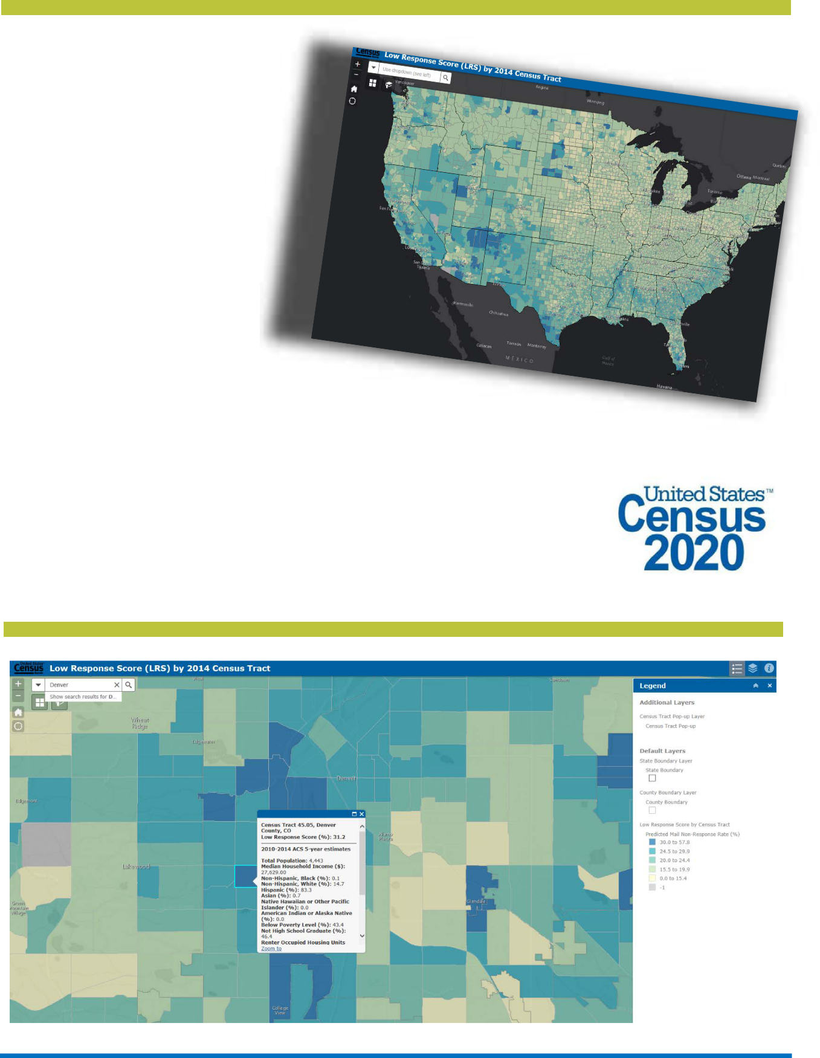

20XX Census Complete Count Committee Training Manual 17

Chapter 6

20XX Census Integrated Communications Campaign

ON THE ROAD TO 20XX

Overview

Building on the lessons learned from the 2010 Census, the 20XX Census will conduct a fully inte-grated Communications Campaign featuring advertis-ing events, public relations, and partnership activi-ties. The public relations objective for the Integrated Campaign is to surround every household in the country with credible, memorable messages through trusted conversations that motivate people to respond to the census.

Additional Resources

The Census Bureau plans to provide materials that will be customizable, allowing partners the flexibility to include additional information and graphics. Many others will be turnkey and can be dropped into a newsletter or posted on a partner’s Web site.

All materials will include consistent messaging to maximize the effectiveness of communications across the regions.

The Census Bureau is hiring for 20XX. Information

on available positions and how to apply can be found at Census Jobs Web site at <20XXcensus.gov/jobs> (to be activated later).

General Operational Timeline

The 20XX Census Integrated Communications Campaign, that includes the integration of paid advertising, public relations, special events, market-ing, Statistics in Schools, and promotional efforts, will rely heavily on partner participation and outreach at both the national and local levels. The Census Bureau plans to launch he campaign with an Awareness phase beginning in January 20XX. In March 2010, the focus will shift from Awareness to Motivation, encouraging people to respond immediately. The Reminder phase will begin in May 20XX, and will not only encourage immediate response, but will also encourage those that have not responded to cooper-ate with the census enumerators when they are vis-ited. Finally, there will be a Thank You phase where the Census Bureau thanks everyone for their assis-tance and participation.Key dates of the 20XX Census operational timeline include:

20XX Census Complete Count Committee Training Manual | 19

hapter 7

What to Expect From Your U.S. Census Bureau Staff Liaison

THE ROLE OF PARTNERSHIP SPECIALISTS

Program Implementation

Partnership specialists are the primary contact between the U.S. Census Bureau and the SCCC/

- They serve as technical advisors and informa-tion resources to SCCCs/CCCs. However, they will not manage the SCCC/CCC in any way.

Partnership Specialists help the committees identify census awareness building activities that are most effective in their community. They will (depending on funding) also provide promotional materials to tribal and local governments and community organizations throughout the SCCC/CCC formation and implemen-tation process.

Here are some steps partnership specialists will follow to assist local governments:

- Meet with all local governments in the area to encourage the formation of SCCCs/CCCs to pro-mote the importance of the 20XX Census and increase participation.

- Provide orientation/training for SCCC/CCC leaders or chairpersons, including information needed to form the committee, the characteristics of effective chairpersons, the various subcommittee structures, and possible actions.

- Provide technical support to SCCC/CCC chairpersons.

- Assist SCCCs/CCCs in developing a strategy and work plan.

- Attend, when possible, SCCC/CCC meetings, pro-vide guidance, recommend possible outreach and promotional activities, and distribute promotional materials and items, as available.

- Encourage the development of innovative activities geared to specific groups within the community.

- Maintain an open line of communication with SCCCs/CCCs. This will lead to a more collaborative relationship and more effective SCCCs/CCCs.

20XX Census Complete Count Committee Training Manual | 21

Chapter 8

Summary and Closing

Summary

This SCCC/CCC training manual provides SCCC/

- leaders and members the information needed to form strong and effective committees. By drawing on the local knowledge of the committee and census data, the SCCC/CCC will develop focused and effi-cient to support the 20XX Census.

- SCCCs/CCCs speak the language of the commu-nity and know how to best reach residents.

- SCCCs/CCCs help ensure an accurate 20XX Census count.

- SCCCs/CCCs increase the participation ratio and the response rate in their communities.

Closing

This session was intended to provide SCCC/CCC leaders/members with tools to train their team. We have provided some basic information about the U.S. Census Bureau and covered some essential elements of successful SCCCs/CCCs. The most suc-cessful SCCCs/CCCs will use this information in this guide to create mixes promotions, messaging, and local grassroots outreach tailored to their respective communities.

Evaluations—Please complete the evaluation form in your packet of materials and return it to your trainer. Thank you for your time, attention, and commitment to this important effort.

20XX Census Complete Count Committee Training Manual | 23

